AI ASSISTED CODING

LAB RE-EXAM-3

NAME : G.Ashish

HT.no : 2403A52110

BATCH : 04
+
Q1:
Scenario: In the domain of Transportation, a company is facing a challenge related to algorithms
with ai assistance.
Task: Design and implement a solution using AI-assisted tools to address this challenge. Include
code, explanation of AI integration, and test results.
Deliverables: Source code, explanation, and output screenshots.
Prompt:
DESIGN A SIMPLE PYTHON PROGRAM THAT USES TO FIND SHORTEST ROUTE BETWEEN BUSSTOPS.

CODE :
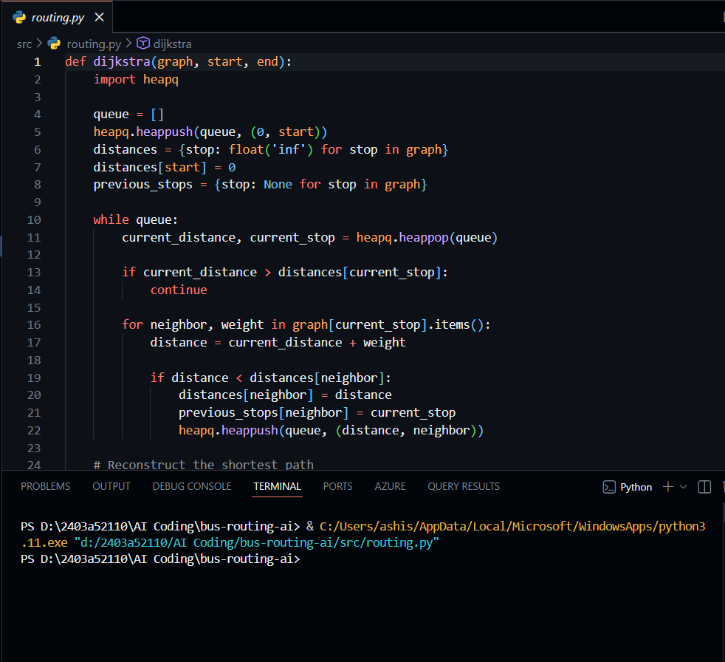

Observation
1. The algorithm successfully finds the shortest route between the given bus stops.
2. The test results show that even for multiple paths, the program correctly chooses the minimum distance path.

Q2:
Scenario: In the domain of Finance, a company is facing a challenge related to data structures with ai.
Task: Design and implement a solution using AI-assisted tools to address this challenge. Include
code, explanation of AI integration, and test results.
Prompt :
DESIGN A SIMPLE PYTHON PROGRAM THAT USES TO ANALYSE THE STOCK PRICE DATA
CODE :

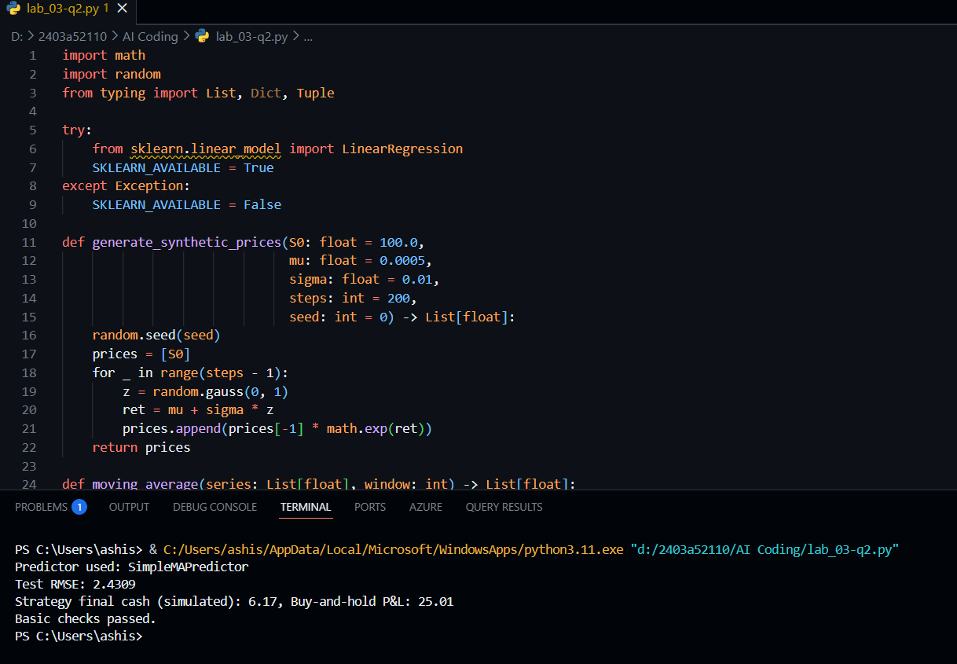

Observation:
1. The program correctly stores stock prices using simple data structures like lists or dictionaries.
2. The calculated average, highest, and lowest prices match the expected values from the input data.

